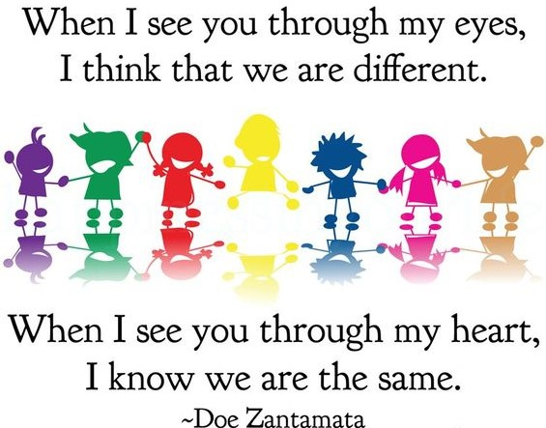
Defining "multicultural". Start by underlining the prefix "multi" and asking participants what this prefix means. Responses will include "many," "varied or various," "different," and so on. Affirm all answers, then summarize. This portion should take only a couple minutes. Next, move on to "-cultural." What does this term mean? Encourage participants to define "cultural" both in terms of what they believe a dictionary-type definition would be and what it means to them individually.
Categorizing list items. The next step is to divide the items into categories, which will make the final step of the exercise much easier. Indicate this intention to the group, and mention that you will be using Nitza Hidalgo's "three levels of culture." The citation for this model is:
Hidalgo, N. 1993. Multicultural teacher introspection. In Perry, T. and Fraser, J. (Eds.) Freedom's Plow: Teaching in the Multicultural Classroom. New York: Routledge.
Hidalgo's levels include:
- the Concrete: This is the most visible and tangible level of culture, and includes the most surface-level dimensions such as clothes, music, food, games, and so on. These aspects of culture are often those which provide the focus for multicultural "festivals" or "celebrations."
- the Behavioral: This level of culture clarifies how we define our social roles, the language we speak, and our approaches to nonverbal communication. The Behavioral level reflects our values. Aspects to be listed in this category include language, gender roles, family structure, political affiliation, and other items that situation us organizationally in society.
- the Symbolic: This level of culture includes our values and beliefs. It can be abstract, but it is most often the most important level in terms of how individuals define themselves. It includes value systems, customs, spirituality, religion, worldview, beliefs, mores, and so on.
After discussing why "the Symbolic" is the most important category for most people, refer them back to the lists. Several questions will lead to interesting conversation:
- When you meet somebody, which of those items (under any of the categories) do you use to understand them culturally?
- Is your attempt to understand others culturally consistent with how you want to be viewed and understood?
- What forces in our society might contribute to our simplification of others' cultures, even though we don't want to be defined simplistically ourselves?
Point out that this exercise is not meant to indict anyone, but instead to highlight how forces ranging from the media to our own educations can move us backwards when we think we are experiencing progress in self- and social development. The conversations that happen as a result of this activity can last 10 minutes or over an hour, depending on what questions you ask and what direction you take.
This activity also provides an excellent opportunity to introduce the link between critical pedagogy and multicultural teaching. The process highlights the dimensions of diversity and culture within the room of folks with whom you are working. This illustrates how the most important multicultural resources are the participants themselves, and instead of trying to define what is culturally important to them through special celebrations or additive techniques, it is our responsibility to draw them into the conversation, and allow them to define themselves.

http://education.byu.edu/diversity/activities.html

http://www.edchange.org/multicultural/activities/multicultural.html

